**School of Electrical and Computer Engineering**

**RESEARCH INTERNSHIP REPORT**

Name: _____신선우 _ / Student ID :_____20131329_____

Advisor: _____Prof. Kyunghan Lee______

School: ________ _ ECE_____ ___ ______ Grade: Senior

1st Track: ________ ___ CSE______ _  2nd Track: _______MAE__ __ __ _

Starting Date:     19/06/19 (yy/mm/dd)   Ending Date ---19/08/13-------(yy/mm/dd)

Research Topic: WIFI base indoor localization by adapting mobility pattern

This topic presents the design and implementation of indoor localization which locate users position who carry mobile device. This method aim to no modification on user side. Only the system side have to some work. WIFI base indoor localization by adapting mobility pattern can performed by only reading access point(AP)’s received signal strength indication (RSSI) and matching with preprocessed and mapped data.

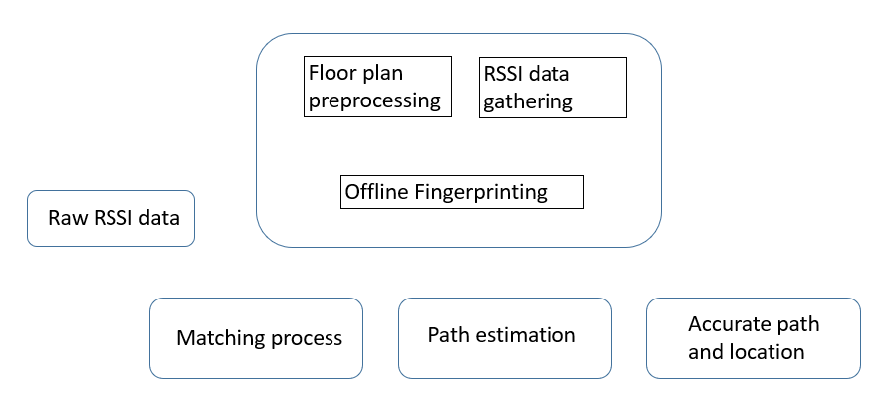

This is system overview.

1. Floor plan preprocessing.

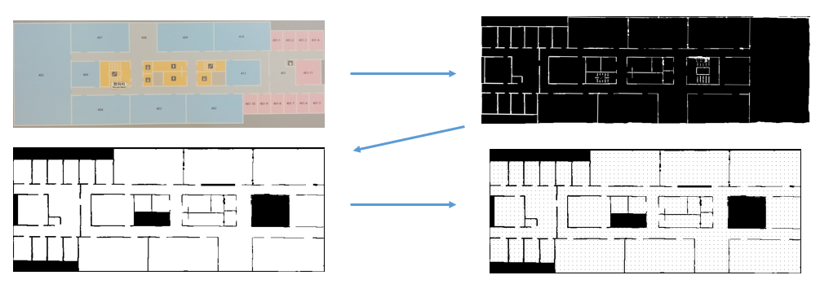

Firstly, I have to preprocess exist floor plan. My experiment area is building 106 floor 4. I take picture with my phone camera in middle of the floor. And, by MATLAB rgb2gray and im2bw, convert camera image to grayscale image and binarize image. By python, flip image bit and make image to node gird to make path.

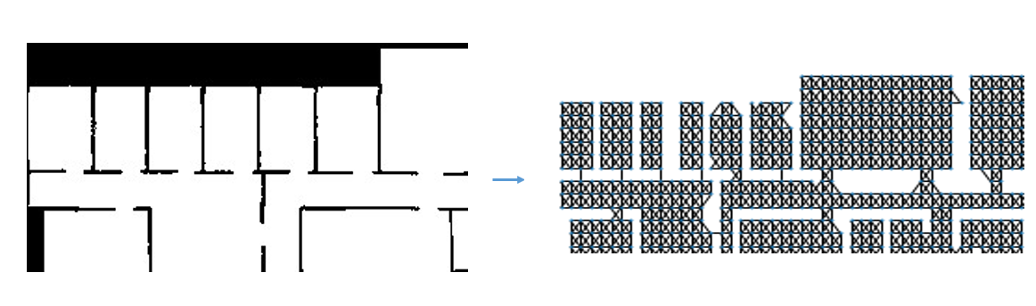

Secondly, Grid map converted as graph nodes. And connect all nodes with edges without wall.

2. Android Apllication : Position Tracking

To collect map data and raw RSSI path data, I have to make an Android application which records position and time stamp. Also It makes a phone scanning wifi continuously.

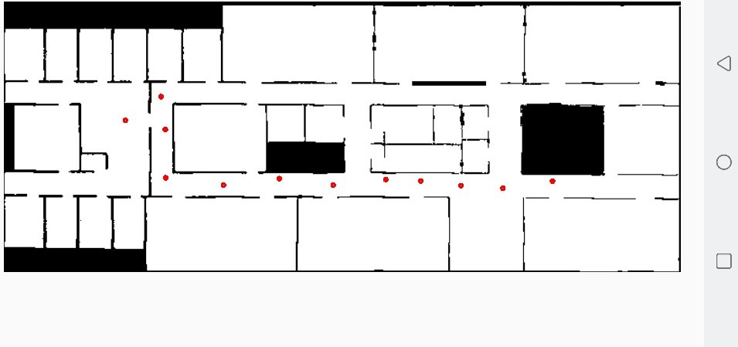

3. Data collection

Our university use Cisco Wireless LAN controller(Cisco WLC 8500). So, I used a program which crawling our university Wireless controller. Which reports AP’s RSSI data.

Firstly, before collecting map data and path data, I had some experiment to figure our university wifi system. By that information, I can get some information of our system and can find way to get right data of our goal.

4. Progress and What’s next?

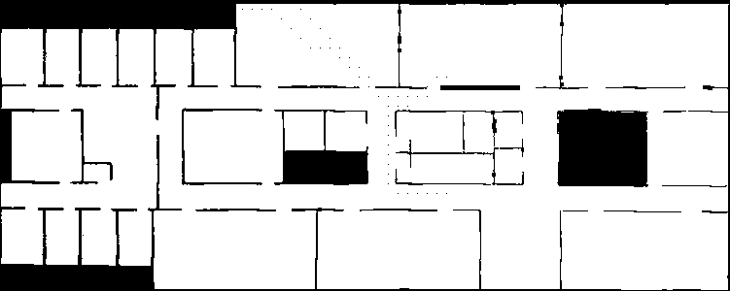

This is test with imaginary path data. Which accuracy is very low so have to collect more data.

In real world, Scanning signal have very high interval. So, my goal is find RSSI tendency of no working of phone, web surfing and video streaming. Localization by these information. I can get more accurate result of localization and path. Additionally, This topic can adapt historical data set.

For example, by 30minutes past information, we can get more accuracy location of present. Also, by future’s information, we can adjust past location.